2014-2015 AVID T-Shirt Order Form
Front Back
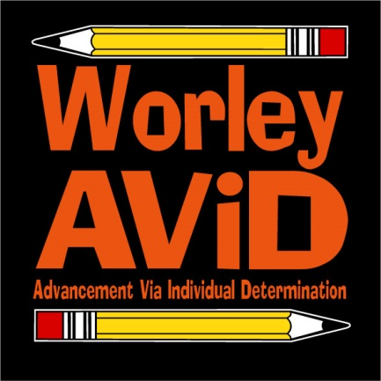

AVID T-shirts are only $15.00. (All shirts are adult sizes)
Child’s Name: __________________________ Grade: _____ Block: _____
Sizes Quantity X Price Cost
Small _____ X $15 = _____
Medium _____ X $15 = _____
Large _____ X $15 = _____
X-Large _____ X $15 = _____
XX-Large _____ X $15 = _____
XXX-Large _____ X $15 = _____
Total: _______________
Acceptable payments: cash or check Make checks payable to: Worley Middle School
Please return order form with payment enclosed no later than Friday, February 20, 2015 at 4:30 p.m.

